MINI HACKATHON-2

Project Group Members
S.No. | Roll No. | Student Name
1 | 2420030082 | manikanta
2 | 2420030083 | srujan
3 | 2420040098 | rahul
4 | 2420090054 | vinay
EXPLAINABLE PREDICTIVE ANALYTICS FOR EMPLOYEE ATTRITION RISK ASSESSMENT
COMPARATIVE ANALYSIS
- Existing Models – Brief Performance Note

Existing employee-attrition prediction models use statistical methods and machine-learning algorithms to estimate whether an employee may leave an organization. Logistic Regression offers a simple, interpretable baseline, while Decision Trees and Random Forests can capture non-linear relationships among factors such as job satisfaction, overtime, tenure, compensation, and work environment. Gradient-boosting models can provide strong predictive performance, but their decisions may be difficult to interpret without additional explanation methods. A key limitation in many implementations is that prediction accuracy is emphasized more than transparent, employee-level explanations and responsible HR use.

- Existing Models – Attrition Prediction Comparison
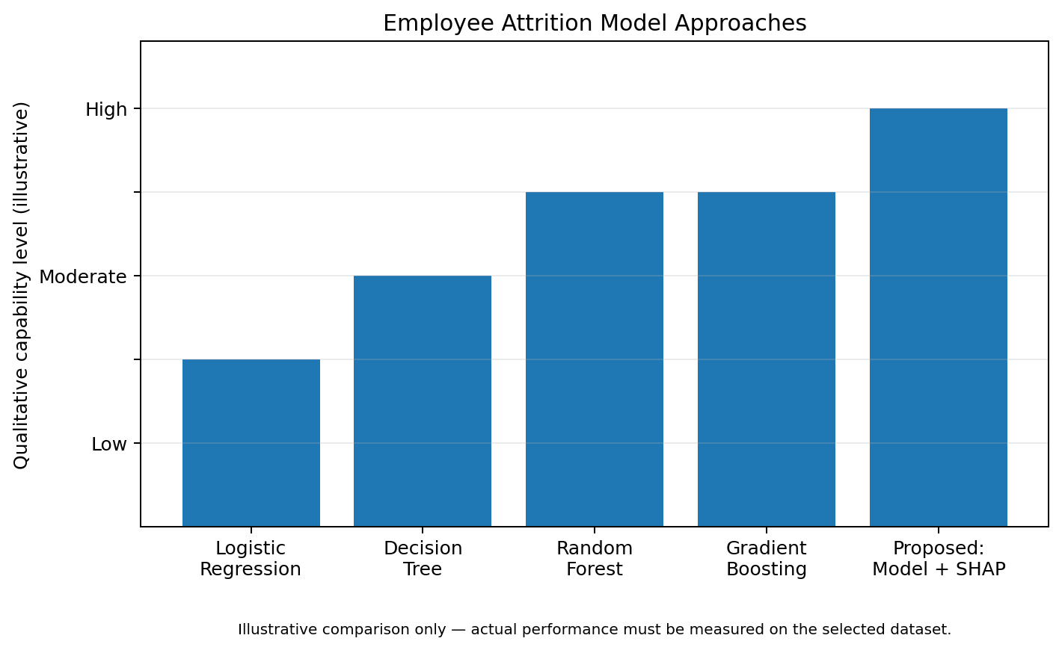
- Our Proposed Model – Brief Evaluation Note

Our proposed system predicts employee attrition risk using HR-related features such as job satisfaction, overtime, years at the company, role, salary band, work-life balance, and promotion history, subject to dataset availability. Candidate models such as Logistic Regression, Decision Tree, Random Forest, and Gradient Boosting will be trained and compared. SHAP (SHapley Additive exPlanations) will explain which features contribute to an individual prediction and in what direction. Performance will be evaluated using Accuracy, Precision, Recall, F1-score, ROC-AUC, and a Confusion Matrix. A simple dashboard can present risk levels and explanations for authorized HR users.

- Proposed Model – Evaluation Metrics

Metric | What it measures
Accuracy | Overall proportion of correct attrition predictions
Precision | How often predicted attrition cases are actually attrition cases
Recall | How many actual attrition cases the model successfully identifies
F1-Score | Balance between Precision and Recall
ROC-AUC | Ability to distinguish employees who leave from those who stay across thresholds
SHAP Explanation | Shows which features contribute to an individual prediction and their direction

- Proposed Model – Evaluation Framework Graph
- Key Difference
